Exercise 1.14 (Change of measure for an exponential random variable). Let X be a nonnegative random variable defined on a probability space 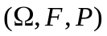 with the exponential distribution, which is
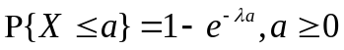
whereλis a positive constant. Let 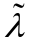 be another positive constant, and define
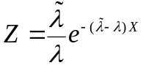
Define by
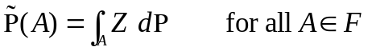
- Show that 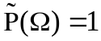.
- Compute the cumulative distribution function for the random variable X under the probability measure .

※( Thm 1.6.7 Randon-Nikody’m)
and are equivalent probability measures defined on 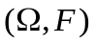.
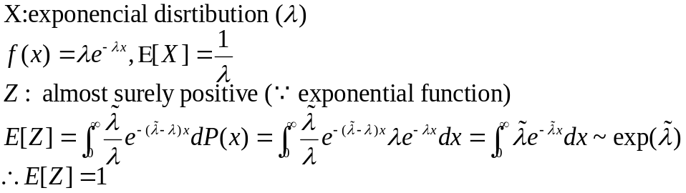
(i)
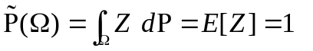
(ii)
